Develop a Mini Project with GitHub Integration and Jenkins CI/CD Pipeline

Installing GIT:
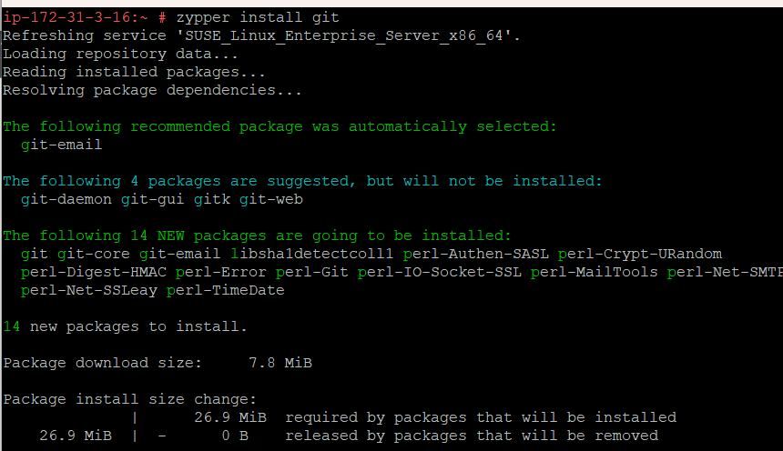

Configuring GIT
Creating the file to push into the GitHub
Entering the credentials:

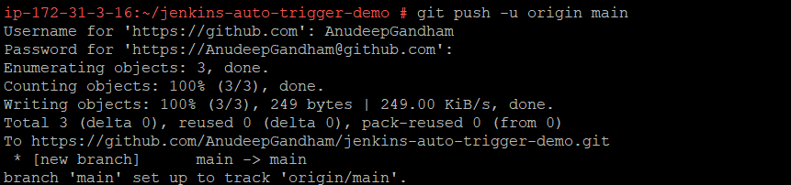
Connecting Jenkins and GitHub
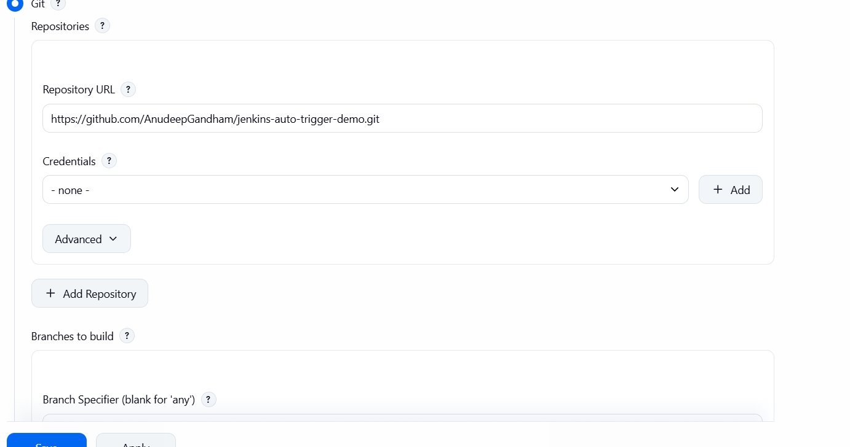
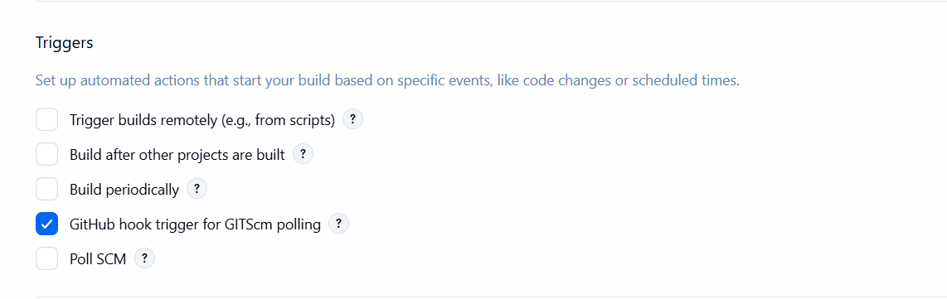

Connect Github to Jenkins
